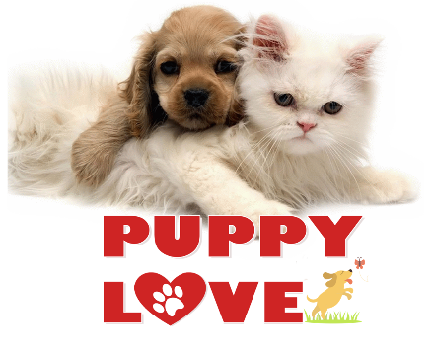**Quest 3**

|  |  |
| --- | --- |
| Team Members: | 1. Lucas 2. Lance |
| Instructions: | * According to several studies, the industry values documentation and excellent written and oral communication skills. The purpose of this part of the class is to encourage you to gain these skills. * Rename this document, fill-out this form, and submit it to the same link where you retrieved this material. * Backup your work; you may need this in the future or as part of an exam. * Organizations value attention to detail. As part of cultivating a culture of producing quality products and due diligence, please review your work at least twice before rendering them to your professor. Remember that resubmissions are not allowed. Thank you for your willingness to improve and to embrace an engineer's mindset. |

Puppy Love is a famous vet clinic/hospital for non-human animals in Massachusetts. The company employs veterinary surgeons, physicians, and health care professionals for its constituents' pets. People bring their precious dogs, cats, other pets, and the clinic diagnoses, treat diseases and disorders, administers medicine, and mediates injuries. The facility keeps track of customers and their beloved family members, taking note of allergies, medications, and other vital information. Moreover, Puppy Love values its workers and makes every effort to keep them employed for most of their working lives. You and your team's job is to draw a normalized entity-relationship diagram (ERD) to support their business. You may use Paint, Figma, Photoshop, draw.io, or other compatibles to create your chart. Show all the tables, their associated field names, and table relationships. Paste your data model design in the Quest document and add any accompanying explanations.

The team members of your random group were announced in Canvas. Collaborate with them to complete this quest. To help you in this effort, please digest the information inside "Data Normalization & ERD.docx," which is available under Week #3's folder. Use this information as a guide to come up with all the tables, columns, and relationships you would need to support Puppy Love. Remember that table names are noun-like, and field names are adjective-like. No table is an island; therefore, the majority of your tables must have a relationship with other entities.

Submission Procedure:

1. Only one submission is required per group. Please make sure that all the names of the group members are written on the cover page.
2. Submit your group's work in the discussion board so your peers will learn from your creativity.
3. Each team member will get to review two other teams' work and provide a comment regarding what you like and how they can improve. Hence, individually, you must have at least two entries (feedback) in the forum.

**ERD:**

|  |
| --- |
| C:\Users\008009764\Downloads\Database ER diagram (crow's foot).png |

**ERD Explanations, Justifications, and Rationales:**

|  |
| --- |
| We started with reading through the paragraph, while reading through we noted down all the potential fields we need. After we finished we started working on our customer lookup. Once we finished jotting down all the information for the customer tables we created our Pets table. Once we finished that we realized we should add an animal lookup table. So, we can easily determine the animal species from this lookup table. Next, we needed a payment table for extra security for the customers. Then we added an employee table so we can store the information for every employee, this made us realize we should add an employee id to our pet table, so we can determine which employee assisted with that pet. Next, we created an illness table, followed by a medicine table, we then noticed we needed a bridging table connecting the two since we can determine which medicine treats which illness, and the effects of it. After we created a date lookup table to keep track of what happens on the specific day. Lastly, we created a transaction table, to keep track of all of the purchases. |

**Please do not forget to offer two comments in this week’s discussion board.**

|  |  |  |  |  |
| --- | --- | --- | --- | --- |
| GRADING RUBRIC | | | | |
| Grading Criteria | 3  **Exceeds**  *Excellent*  Epic Wow | 2  **Meets**  *Satisfactory*  O.K. | 1  **Partially Meets**  *Below Expectations*  Not Yet | 0  **Does Not Meet**  *Unacceptable*  Fail |
| **ERD Design –** The data model is appropriately normalized, complete with primary and foreign keys, used the valid symbols, and the table relationships of one-to-many are correctly wired. | ERD is excellent and understandable :50% | ERD is satisfactory :40% | ERD is obfuscated, or hard to follow :30% | Unfortunately, no ERD. |
| **Collaboration –** You participated in the creation of the data model and actively contributed to the ensuing team conversations and presenation. | Collaboration is excellent :15% | Collaboration is satisfactory :10% | Collaboration is deficient :5% | Unfortunately, no collaboration. |
| **Discussion Board –** The student provided meaningful and constructive feedback to two other group's work in a timely manner. | Excellent contribution it the forum :20% | Satisfactory discussion board entries :15% | Discussion board entries are deficient. :10% | Unfortunately, no discussion board contribution. |
| **Time Management –** candidate used time wisely during development, presentation, and all aspects of the work submitted in a timely fashion. | Work submitted promptly :15% | Submitted within the allotted time :10% | Submitted late :5% | Unfortunately, too long, too short, or untimely. |